Visual Merchandising

There are four elements of visual merchandising, which are:
- Storefront
- Store Layout
- Store Interior
- Interior Displays

Storefront
- A customer’s first impression of a retailer is influenced by the exterior of the business.
- The exterior is commonly known as a storefront.
- The storefront consists of the exterior signs and logos, display windows, entrances, outdoor lighting, landscaping and the building itself.
- All the elements of a storefront represent the brand of the business.
- Exterior signs and logos help identify the business and help brand it.
- Display windows are used to show merchandise and entice customers to enter the store.
- The entrance, or front door, should be inviting, easy to locate and indicate business hours.
- Outdoor lighting is important to create visual appeal. It is also necessary for the safety of customers and employees.
- Landscaping adds color and makes a business look more inviting.
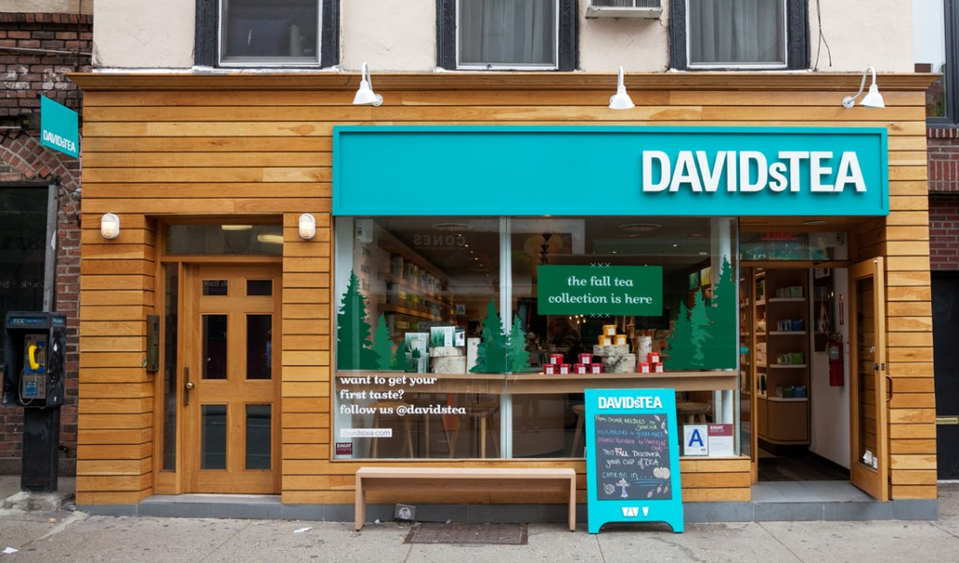

Store Layout
- Store layout is a floor plan that shows how the space in a store is used. It is basically a diagram or map of specific areas within a business.
- The layout should show the size of each space, as well as the arrangement and location of fixtures and aisles. (i.e. cash register, fitting rooms, washrooms, employee areas).
- When designing a layout, it is important to consider the following:
  - Receiving/storage areas should be located near the loading dock area, typically at the back of the stores.
  - Employee areas (e.g. lunch room, office space) should be located in the least valuable, out-of-the-way places.
  - Customer areas (e.g. customer service desk, fitting rooms) should be located out-of-the-way to help increase customer movement in the store.
Types of Store Layouts
- There are many store layouts a retailer may use.
- Floor plans are dictated by the type of business and what works best for customers.
- Some examples of floor plans include:
  - Free-flow layout
  - Racetrack layout
  - Grid layout

- Free-flow Layout
- This type of layout:
  - Is often used in specialty stores, boutiques and apparel stores to create a unique atmosphere.
  - Consists of various fixture shapes and aisle patterns.
  - Allows for an unstructured flow of customer traffic.
  - Is designed for customer convenience and merchandise exposure.
  - Great for small spaces.
  - Most likely to create an experiential retail space.
- Racetrack Layout
- This type of layout:
  - Consists of a major aisle that loops through the store, allowing customers to visit several departments.
  - This maximizes product exposure and is easy to place promotions throughout the store.
  - It allows for displays and arrangements that encourage customers to complete the loop.
  - IKEA is an example of a retailer that uses this floor plan. Customers start at the beginning and are guided throughout the store to the cash registers at the end.
  - A con of this can be that customers don’t get to browse at will and it may waste a customer’s time who knows what they’ve come for.
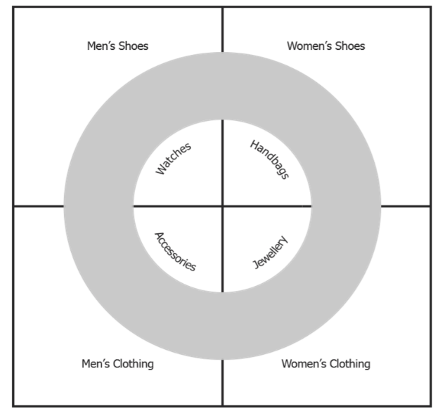
- Grid Layout
- This type of layout:
  - Is used mostly by large retail supermarkets.
  - Consists of straight parallel aisles, with secondary aisles running perpendicular to the main aisles.
  - Impulse purchases are near the front and staple items are at the back.
  - If you ever wondered why milk is at the far end of a grocery store, it’s because this design forces customers to walk past a variety of impulse purchase items both on the way to and from the staple item that they need.
  - The ends of the aisles are prime spots for promoted products and displays.
  - Facilitates efficient use of space and is familiar to shoppers.

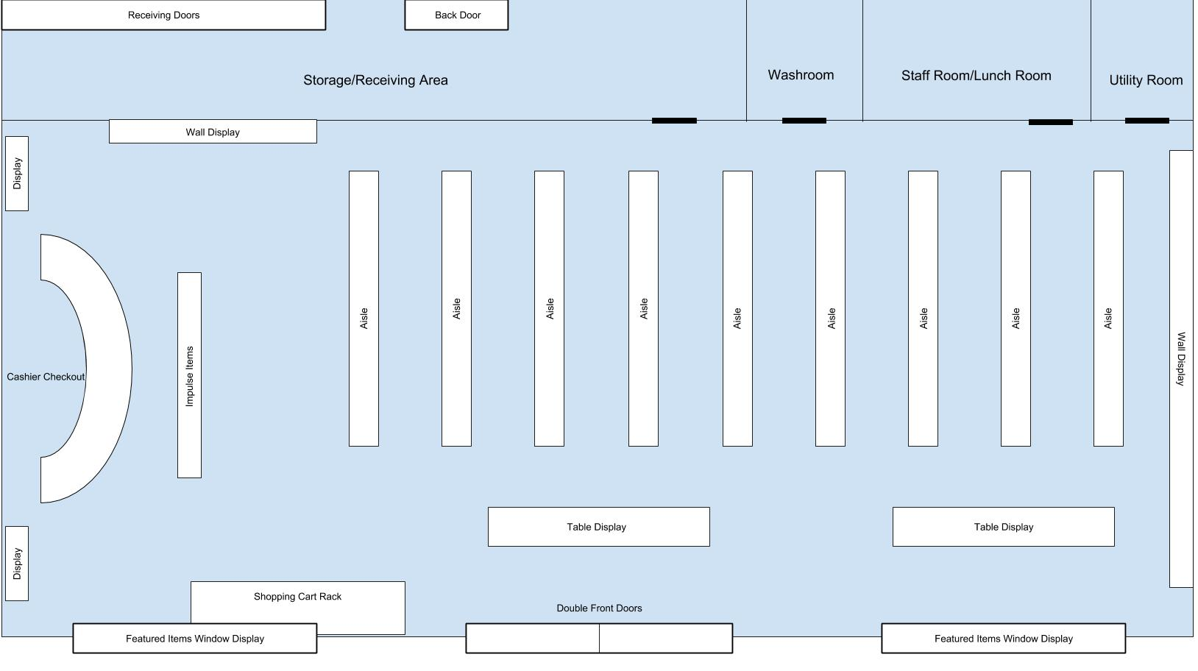

Store Interior
- The store interior refers to everything on the inside of a store.
- Retailers put a lot of thought into things such as paint colour, fixtures and lighting.
- Fixtures and equipment are chosen with the store’s image in mind, as well as the merchandise that is displayed.
- Skillful use of colour can motivate customers to buy based on attracting their attention and creating moods.
  - Visual merchandisers are aware of how color can create moods and use this to create a visual message for the store image.
  - The retailer’s challenge is to create a successful color palette that influences the customers in a positive way.

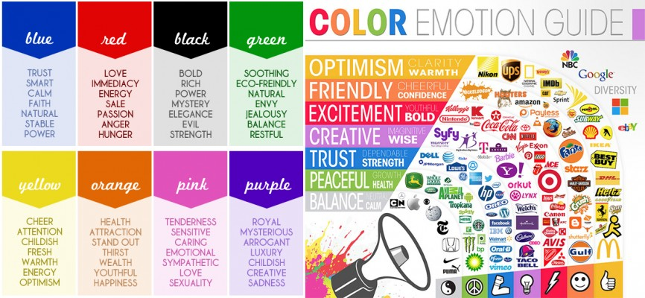

- Lighting is a vital part of the design because it creates an overall atmosphere for the store. It can lead them through the store, call attention to specific merchandise and create certain themes.
- Background music plays a role in defining a store’s image. For example, many stores that target teenage customers will play loud, upbeat music. The Disney Store will play Disney songs. A supermarket may play quiet soothing music.
- Smell has an influence on a store’s image. Many retailers intentionally use certain scents inside their stores to enhance the store image.
  - Starbucks: the scent of fresh coffee fills each location. They sell food too, but you don’t smell it — that’s by design.
  - Cineplex: the smell of movie-theatre popcorn in every corner of the building. It doesn’t matter that they also sell pizza, nachos, and other foods. Their scent brand is fresh popcorn.
  - Lowe's: the scent of freshly cut wood. You may never see a single 2x4 cut in store, but that smell is somehow always there. It's meant inspire us to renovate our homes.

Interior Displays
- Displays help sell merchandise and reinforce a store’s image.
- A display is a presentation of merchandise designed to attract customers.
- Throughout the year, retailers will use displays to draw the customer into the store, to promote items, to announce a sale, or to launch a new seasonal holiday. If displays are not changed periodically, customers will think they have nothing new to offer.
- All displays require artistic and creative flair.

There are various types of displays retailers use:
- A point-of-purchase display is a special display usually found near a cash register. The displays sometimes hold impulse items.

- An open display is a display from which a customer can pick up an item. A clothing rack is an example of an open display.
- A closed display is a case that can be locked. Such as jewelry or electronics.
- An architectural display is one that shows items in a way that customers can image how the items would look in their home, such as a dining room set with a seasonal centerpiece on the table and place settings.
- A window display helps attract customers and create a first impression. These will show products and promotions, such as a table showing seasonal items or a wall showing featured sales.
- A shelving display will strategically place items on the shelves, usually at the end of an aisle.
- A table display are displays designed on table tops, usually showcasing featured or new items.
- A wall display will have mounted merchandise and fixtures displayed on the wall. This is a great use of space, especially if you have a smaller store.

